Dominic Drury

10/30/2023

CS-340

2-1 Assignment: CRUD in MongoDB

1. Access the dataset for this assignment, city_inspections.json, in the /usr/local/datasets directory in your Apporto environment. Using the mongoimport tool and documents found in the city_inspections.json file, load the database “city” into the “inspections” collection. Complete this task by typing the following commands in the Linux terminal to perform the import in the right directory:

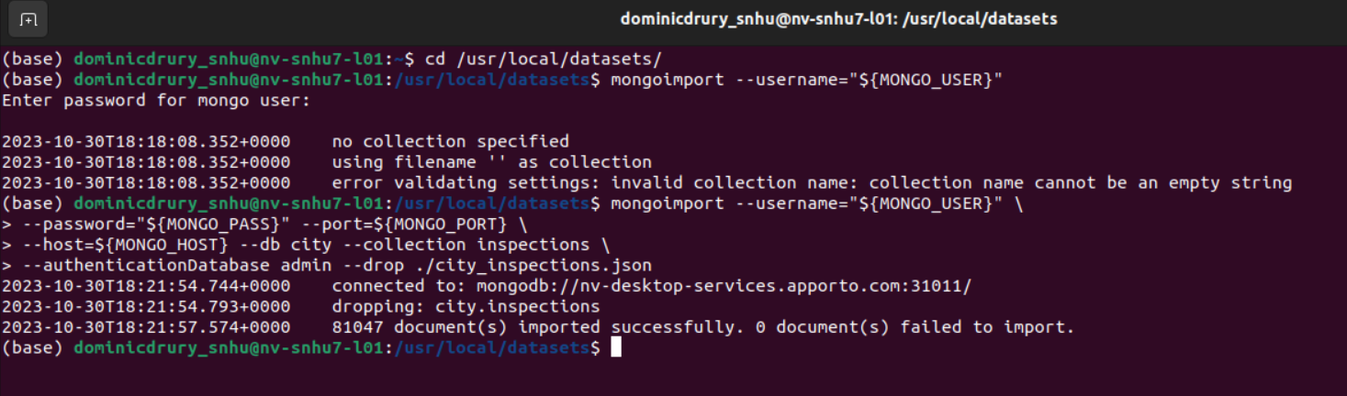

2. Verify your load by “using” the “city” database, and issuing the following queries in the mongo shell:

db.inspections.find({"id" : "10021-2015-ENFO"})

db.inspections.find({"result":"Out of Business"},{"business_name":1}).limit(10)

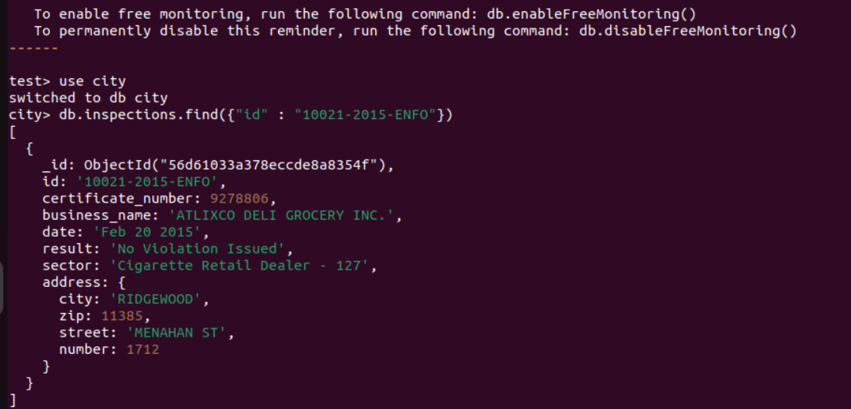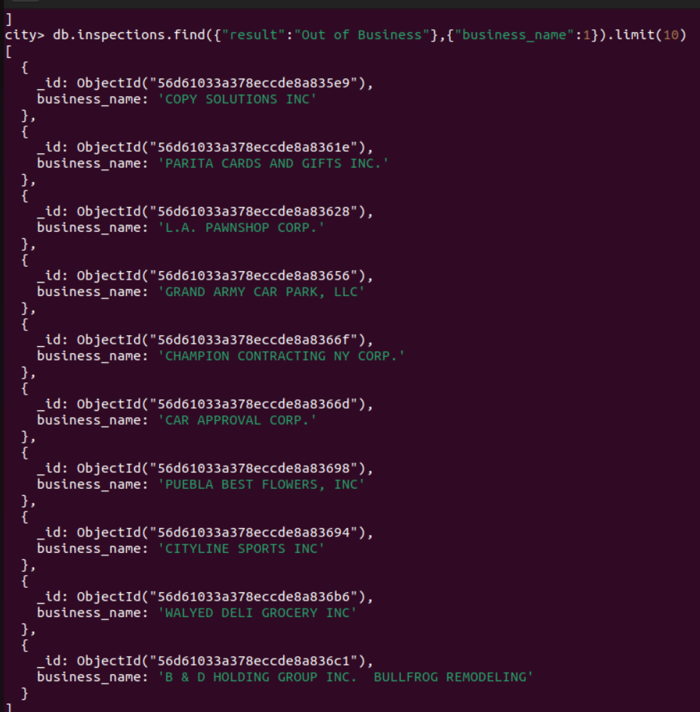

3. Using the appropriate commands in the mongo shell, insert a document to the database named “city” within the collection named “inspections.”

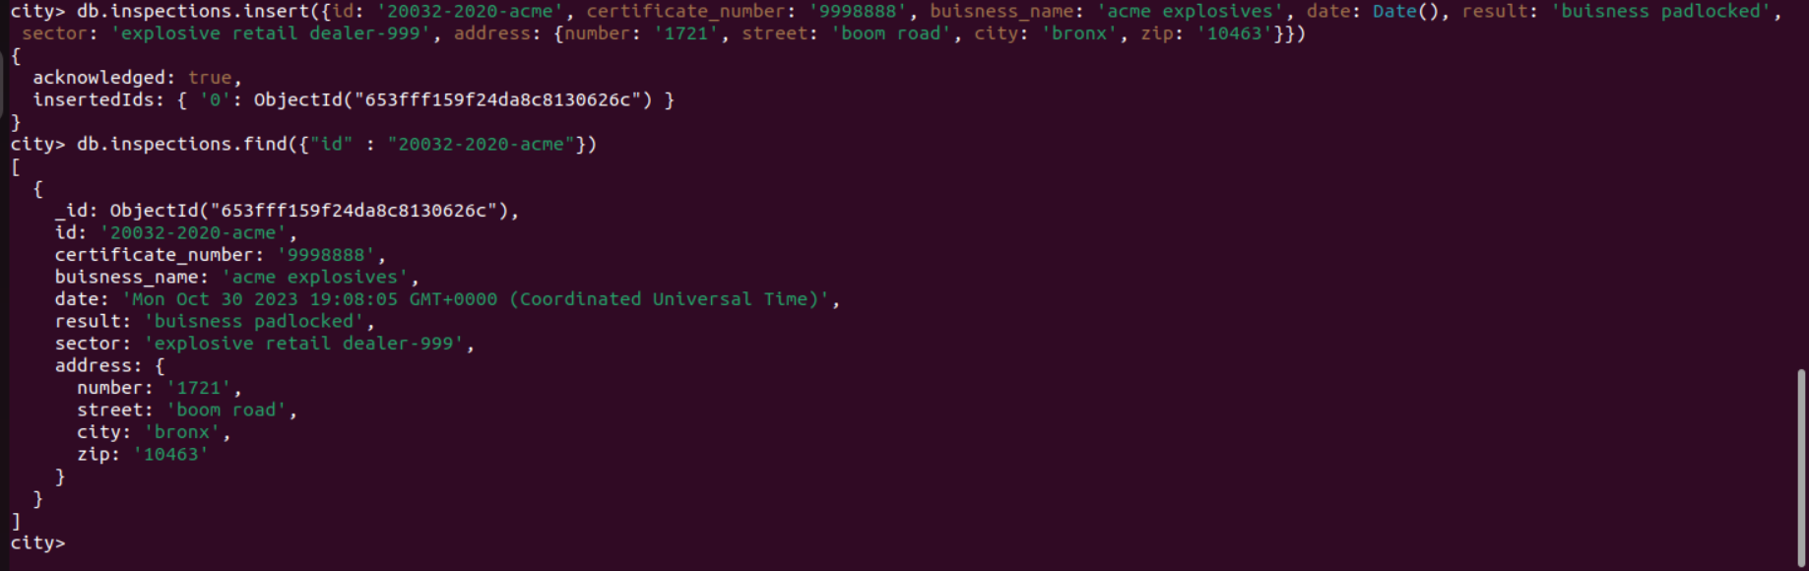

4. Answer the following questions using MongoDB queries.

1. What is the distinct list of inspection “sector” in the current inspections collection? How many are in the list?

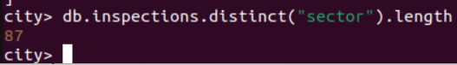

1. What is the difference in the date data type for the business named “AUSTIN 2012” versus your business document insertion of “Acme Explosives”?

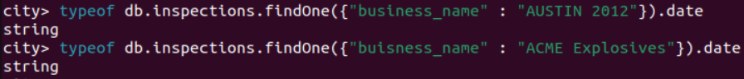

1. How many businesses have a “Violation Issued”?



5. Using the appropriate command in the mongo shell, update the document with the ID “20032-2020-ACME” in the collection “inspections” in the database “city” with the information below.

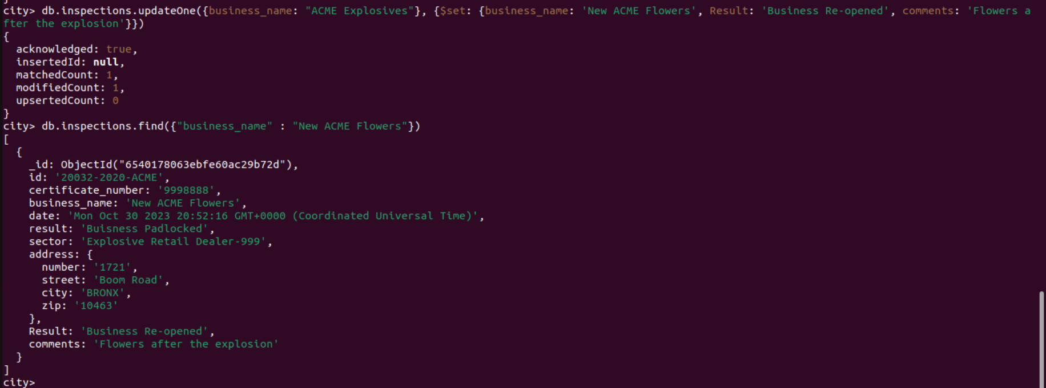

6. Using the database “city” with documents found in the “inspections” collection, perform the tasks listed below. Verify by providing screenshots of the results as evidence.

1. Update all the documents that contain the key-value pair "city":"ROSEDALE" in the address subdocument by changing the zip code in the address subdocument to "76114".

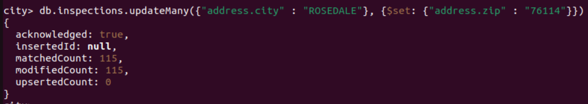

1. Remove the first document with the key-value pair "result":"Violation Issued."

